

`

**B SC. (HONS)**

**COMPUTING**

Assignment Report

iims e-news

|  |  |
| --- | --- |
| **Student name:** | **Student ID:** |
| Momika Shrestha |  |
| Rakshya K.C |  |
| Osaka Thapa Magar |  |

**Course Name**  : Internet Technology

**Semester**  : 1st

**Session**  : May-August, 2016

**Instructor/Examiner/Lecturer** : Mr. Abhinav Dangol

**Submission Date** : 22nd July 2016

# ACKNOWLEDGEMENT

Throughout the assignment, we had to take the help and guideline of some respected persons, who deserve the deepest gratitude. We would like to our acknowledge Mr***. Abhinav Singh Dangol, Course Instructor, International Institute of Management Science*** for giving us a good guideline for assignment throughout numerous consultations. We would also like to thank Mr. Abhinav Singh Dangol for his guidance throughout the session and facilitating us with the required slides for the assignments.

*In addition, we would also like to express gratitude to the* ***UCSI university*** *for providing me the opportunity to attend the course.*

Many people, especially our team mates have made valuable comment suggestions on this assignment which gave us an inspiration to improve the assignment. We thank all the people for their help directly and indirectly to complete the assignment titled as iims e-news'.

Table of Contents

ACKNOWLEDGEMENT i

INTRODUCTION 1

PROBLEM STATEMENT 1

SOLUTIONS 1

DESIGN DOCUMENTS 2

*Database design* 2

*Structure of data base:* 2

*Register table:* 3

*News table:* 4

*User Interface design:* 5

*Login page:* 5

*Sign up:* 6

*Display news:* 7

# INTRODUCTION

The iims e-news is a prototype online news system which was created using the basic HTML, CSS, Javascript, PHP and MySql. This prototype system is capable of adding news into database and displaying it in descending order in the news site using PHP. We used CSS (Cascading style sheet), a style sheet language used to describe and design an HTML document to give styles to our prototype system. We also used MySql, an open source relational database management system based on the structured query language to access and manipulate the database.

# PROBLEM STATEMENT

People these days especially students of it colleges have moved to the paper less system. They rely on technology more. They do not have enough time to read newspaper. They are especially busy with their studies and do not know what especial programs and happening are going on in their college either. So our iims e-news is a prototype online news system made for the iims college student which will allow the students to login to the system and read as well as add news to the system.

# SOLUTIONS

Solutions to the above mentioned problem are:

Creating an online system where students are allowed to view the ongoings of the college and also add news to the system so that others can know about it too.

# DESIGN DOCUMENTS

## *Database design*

### *Structure of data base:*

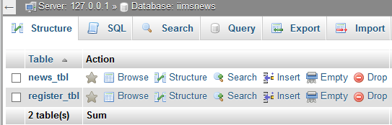**Fig: data base structure**

The database of the iims e-news system is named as iimsnews. This data base consist of two tables namely news_tbl and register_tbl.

We created a file conn.php with following code to connect the database.

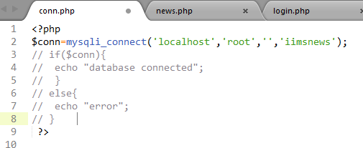**Fig: conn.php**

### *Register table:*

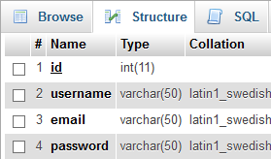

**Fig: register_tbl**

Above is the structure of the register_tbl in the iimsnews database. This table has four columns; id, username, email and password. This table is for storing information which we get during the registration process. We will access this table during the login process. Only the records in this table will be allowwed to access the iims e-news system.

In the above table diagram the first column (Name) is the field name and the second column (Type) describes the data type of the field.

### *News table:*

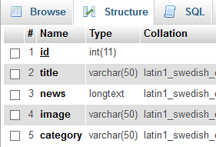

**Fig: news_tbl**

The above is a diagram of the news_tbl. This table is used to insert the news. We access this table both to insert news as well as retrieve news to show in the table. Similar to the register_tbl, this table also has field names and their data types.

## *User Interface design:*

### *Login page:*

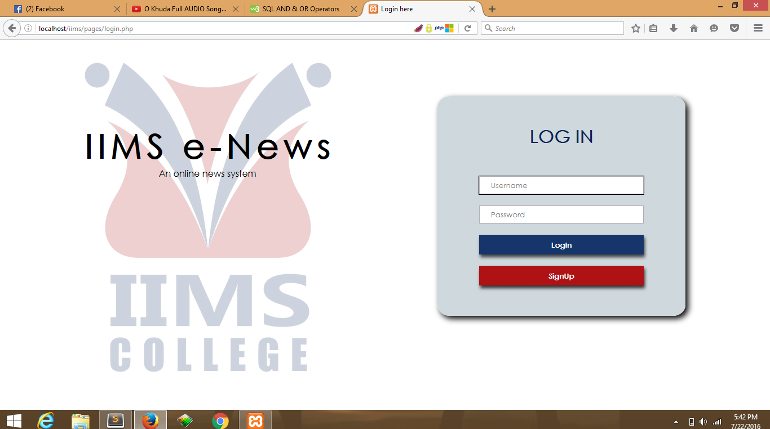

The login page is the first page that will be displayed for the user interaction. This page was solely created using HTML and all the designing was done with css only. There are two fields in the page: username and password. The input in these is further checked into data base and if the username is not logged in.. a java script alert box pops up.

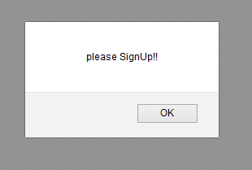

Fig: alert box

### *Sign up:*

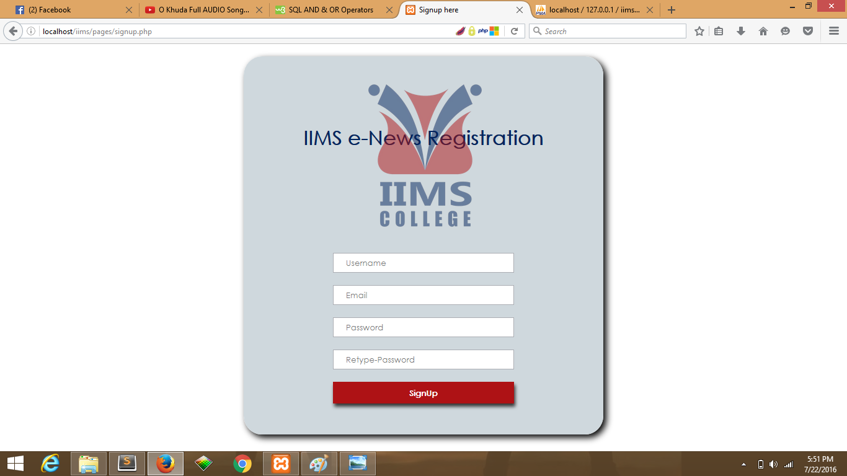**Fig: Sign Up**

This is the sign up page. If user has not yet registered user cannot login so after clicking that sign up button on the login form this form is displayed. We fill the required field and then we click on the sign up button again on this registration form. Only then we will be given the access to the news.

### *Display news:*

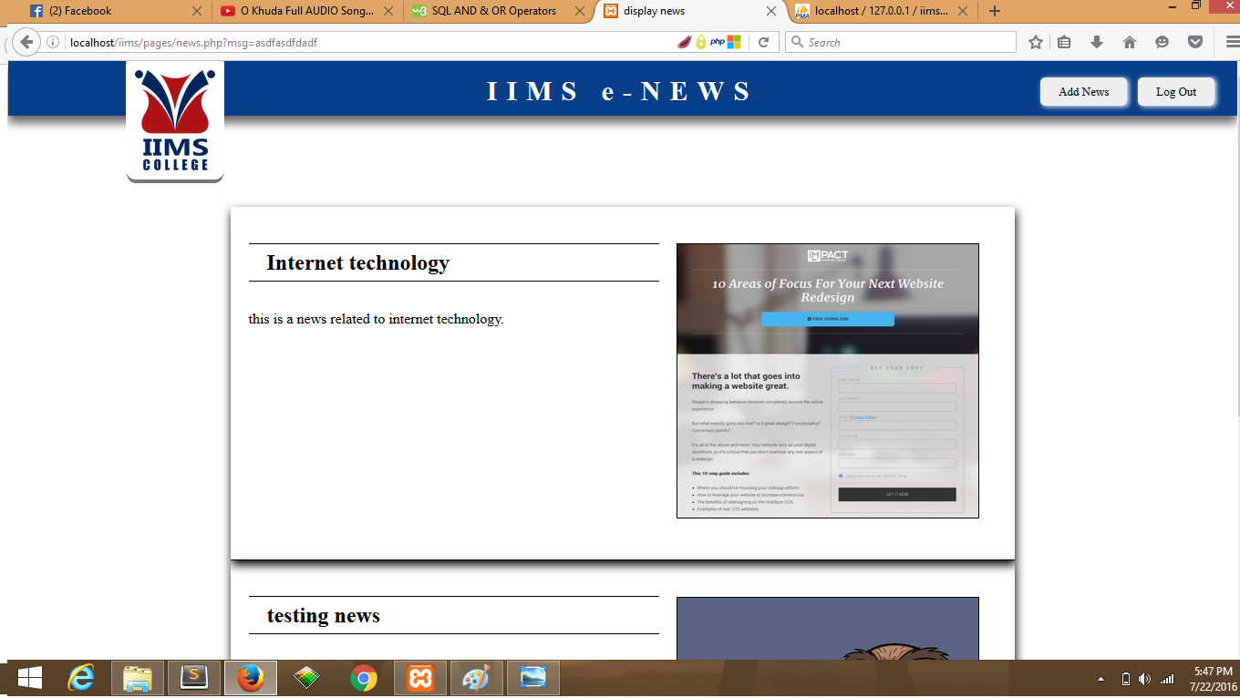

This is the page where we display the news which have been inserted in the data base in the descending order. The logout button on the top corner in the right lets us to logout from the system and takes us back to the login form. Here in this page we can see a add news button as well. We get the following page.

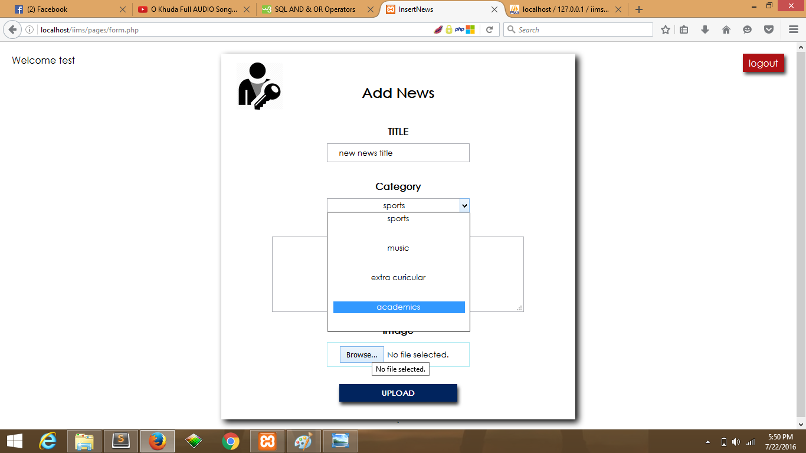

**Fig: add_news**

In this form we have field to enter the news title, a field to select category of the news and also text area to enter the new, we have include a button to select file as well. The news we enter here goes to the news_tbl and stays there which will later be displayed in the news page after pressing the upload button.